FPGA Architecture evaluation flow
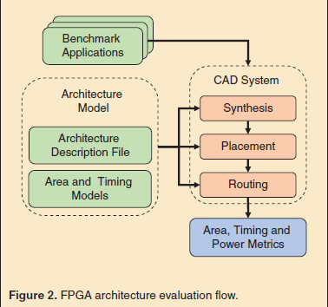
A suite of benchmark applications, an architecture model, and a CAD system.
Benchmark application
- General-purpose platform designed for many use cases.
- Needed when implementing a wide variety of benchmark designs.
Architecture model
- Involves many different decisions from architecture-level organization (# & types of blocks, distribution of wire segment lengths, size of logic clusters & logic elements) to transistor-level (programmable switch type, routing buffer transistor sizing, register implementation)
- Logic blocks & programmable routing: Designed & laid out as full custom circuits.
- Hardened blocks (DSPs) mix standard-cell & full-custom design (block core, peripherals).
- RAM, I/O even include significant analog circuits.
CAD system
- Consist of a sequence of complex optimization algorithms.
- Synthesizes a benchmark written in an HDL into a circuit netlist.
- Maps it to the different FPGA blocks, places the mapped blocks at specific locations on the FPGA.
- Routes the connections between them using the specified programmable routing architecture.
- Total area: sum of the areas of the FPGA blocks.
- Timing analyzer: Finds the critical path through the blocks, routing to determine the max frequencies of the application’s clock.
- Power consumption: Estimated based on resources used and signal toggle rates.

Programmable Logic
Programmable Array Logic (PAL): reconfigurable computing devices.
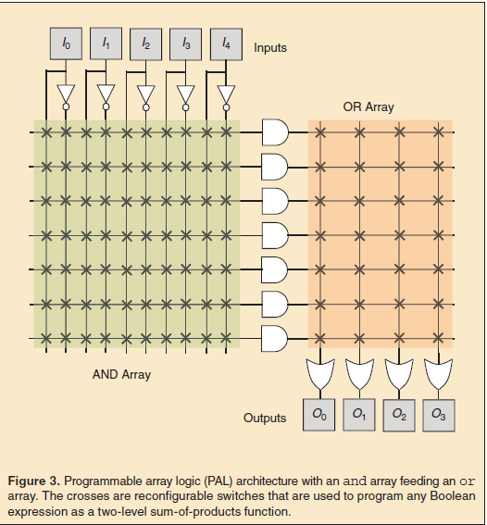
- Implement any Boolean logic expression as a two-level sum-of-products function.
- Achieve configurability through programmable switches that select inputs to each of the and/or gates to implement different Boolean expressions.
- Do not scale well: Logic capacity ↑, wire forming and/or became longer and slower.

Complex Programmable Logic Device (CPLDs)
- Keep and/or arrays as the basic logic.
- Attempted to solve the scalability challenge by integrating multiple PALs on the same die with a crossbar interconnect between them at the cost of more complicated design tools.
Look Up Table (LUTs) based FPGA (Xilinx)
- Consisted of an array of SRAM-based LUTs with programmable interconnect between them.
- Scale very well, with LUTs achieving much higher area efficiency.
- K-LUT → K-input Boolean function by storing its truth table in configuration SRAM cells.
- K-input used as multiplexer select lines to choose output from the $2^{k}$ values of the truth table.
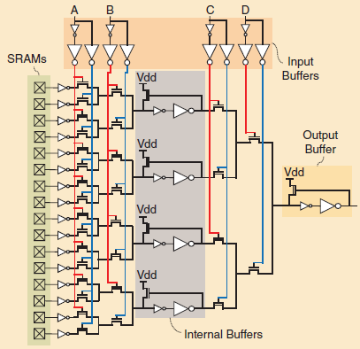
Inside the LUTs
- Using PTL to implement the 4-LUT (4 input A, B, C, D/ SRAM = 16).
- By using internal buffer to mitigate the increase in delay when pass the PTL.
- Area-Delay: sizing of the LUT’s PT, input/output buffers.
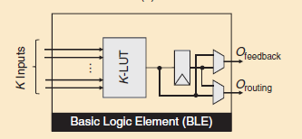
Basic Logic Element (BLE)
- K-LUT coupled with an output register and bypassing 2:1 multiplexers.
- BLE can either implement just a flip-flop (FF) or a K-LUT with registered or unregistered output.
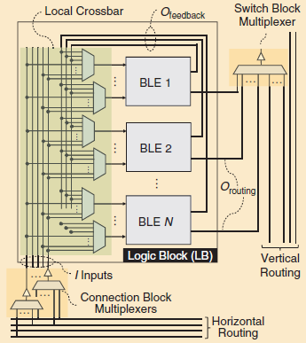
Logic Blocks (LB)
- LB contains N BLEs along with local interconnect. The local interconnect in the logic block consists of multiplexers between signal sources (BLE outputs and logic block inputs) and destination (BLE inputs)
- Multiplexers are often arranged to form a local full or partial crossbar.
- Switch and connection block multiplexers forming the programmable routing that allows logic blocks to connect to each other.
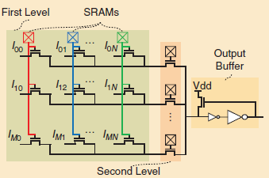
Local Interconnection’s multiplexers architecture
Trade-offs: K increase – decrease # of LUTs, critical path → increase performance
Area increases exponentially with K, speed degrades linearly.
Proper size: LUTs 4-6 and LB 3-10 BLEs, 4 LUT to better area, 6 LUT to higher speed.

Fracturable LUT
Larger LUT’s performance with area-efficiency of smaller LUTs.
- Fracturable {K, M(# of outuput)}-LUT (total ≤K+M inputs) can be configured as a single LUT of size K or can be fractured into two LUTs of size up to K – 1 that collectively use no more than K + M distinct inputs.
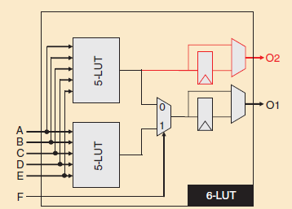
Two 5-LUTs + 2:1 multiplexers
- Requiring the two 5-LUTs to share all their inputs will limit how often both can be simultaneously used.
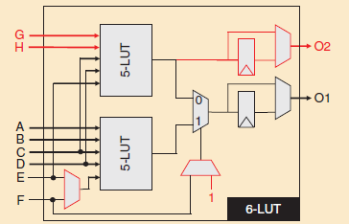
Adding extra routing port
- Increases the area of the fracturable 6-LUT, but makes it easier to find two logic functions that can be packed together into it.

Xilinx – Virtex-5
Chose to minimize the extra circuitry added for fracturability: No extra input routing ports or steering multiplexers are added.

LB size
- Recently announced Versal architecture from Xilinx further increases the number of BLEs per LB to 32.
- First, inter-LB wire delay is scaling poorly with process shrinks, so capturing more connections within an LB’s local routing is increasingly beneficial.
- Second, ever-larger FPGA designs tend to increase CAD tool runtime, but larger LBs can help mitigate this trend by simplifying placement and inter-LB routing.

Number of FFs per BLE
The number of FFs was further increased from two to four per BLE in order to accommodate increased demand for FFs as designs became more deeply pipelined to achieve higher performance.
- Low-cost multiplexing circuitry allows sharing the existing inputs between the LUTs and FFs to avoid adding more costly routing ports.
- Implements FFs as pulse latches instead of edgetriggered FFs.
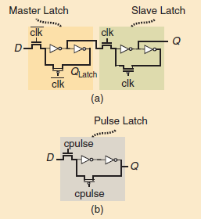
Master-Slave FF to Pulse Latch
- Pulse latch acts as a cheaper FF with worse hold time as it latches the data input during a very short pulse instead of a clock edge as in conventional FFs.
- If a pulse generator was built for each FF, the overall area per FF would increase rather than decrease. Instead, Stratix V contains only two configurable pulse generators per LB; each of the 40 pulse latches in an LB selects which generator provides its pulse input.

Arithmetic Operation
While these operations can be implemented with LUTs, each bit of arithmetic in a ripple carry adder requires two LUTs (one for the sum output and one for the carry).
- Leading both high logic utilization and slow critical path due to connecting many LUTs in series to compute carries for multi-bit additions.
- Hardened Arithmetic circuitry
- To avoid adding expensive routing ports, re-use the LUT routing ports or fed by the LUT outputs.
- Carry bits are propagated on special, dedicated interconnect with little or no programmability so that the crucial carry path is fast.
- Hardening more sophisticated structures like carry skip adders further improves speed.
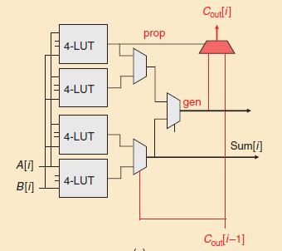
Xilinx’s Arithmetic Operation
- Xilinx hardens the carry logic for 8-bit carry look-ahead adders (Addition can only start on every eighth BLE), while the sum, propagate and generate logic is all implemented in the fracturable 6-LUTs feeding the carry logic

Programmable Routing
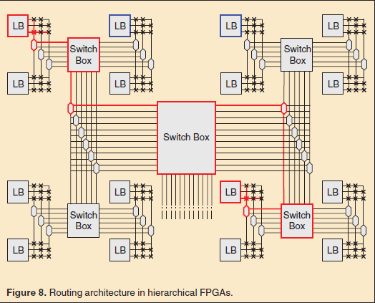
Hierarchical style
- Communicate to more distant regions of a hierarchical FPGA, a connection (highlighted in red) passes through multiple wires and switches as it traverses different levels of the interconnect hierarchy.
- Very long wires, needing more wires to connect.
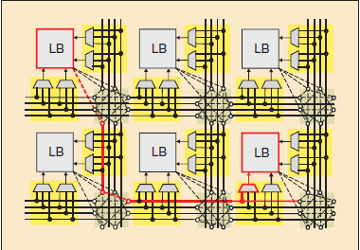
Island style
- Regular two-dimensional layout of horizontal and vertical directed wire segments can be efficiently laid out.
- Routing wire segments
- Connection blocks (multiplexers)
- Switch blocks (programmable switches)

On-Chip Memory
The first form of on-chip memory elements in FPGA architectures was FFs integrated in the FPGA’s logic blocks.
No single RAM configuration (capacity, word width, number of ports) used universally in FPGA designs, challenging to decide on what kind of RAM blocks should be added to an FPGA such that they are efficient for a broad range of uses.
BRAM (Block RAMs)
- Hard functional blocks for memory.
- Consists of an SRAM-based memory core, with additional peripheral circuitry to make them more configurable for multiple purposes and to connect them to the programmable routing.
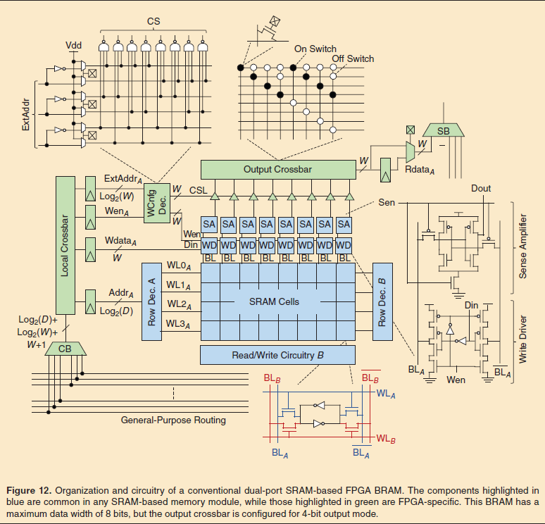
- Two-dimensional array of SRAM cells to store bits, peripheral circuitry to access to these cells.
- All modern FPGA BRAMs register all their inputs.
- Write operation
  - Column decoder activates the write drivers, which in turn charge the bitlines (BL and $\overline{BL}$) according to the input data to-be-written to the memory cells.
  - Row decoder activates the wordline of the row specified by the input write address, connecting one row of cells to their bitlines so they are overwritten with new data.
- Read operation
  - Both the BL and $\overline{BL}$ are pre-charged high and then the row decoder activates the wordline of the row specified by the input read address.
  - Contents of the activated cells cause a slight difference in the voltage between BL and $\overline{BL}$, which is sensed and amplified by the sense amplifier circuit to produce the output data.
Architecture Decision
- Capacity: area (SRAM cell) <linear> capacity, area (peripheral, # of routing ports) <sub-linear>capacity.
Larger BRAMs have lower area per bit, making large on-chip buffers more efficient.
Application requires only small RAMs, much of the capacity of a larger BRAM may be wasted.
- Data word width: larger data width can provide higher data bandwidth to downstream logic.
Costs more area than a BRAM with the same capacity but a smaller word width, as the larger data word width necessitates more sense amplifiers, write drivers and programmable routing ports.
- Number of r/w ports: increasing the number of read/write ports to a BRAM increases the area of both the SRAM cells and the peripheral circuitry, but again increases the data bandwidth the BRAM can provide and allows more diverse uses.
Interface to the programmable routing fabric
- Easier to create a routing architecture, balances flexibility and cost well if all block types connect to it in similar ways.
- Connection block multiplexers, followed by local crossbars in some FPGAs, form the BRAM input routing ports, while the read outputs drive switch block multiplexers to form the output routing ports.
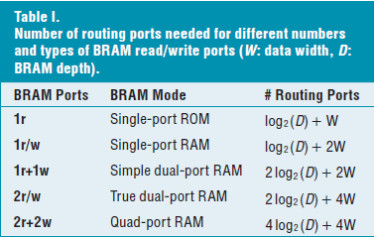
- Minimizing # of routing ports to a BRAM without unduly comprising its functionality.
- While true dual-port memory is useful for register files, caches and shared memory switches, the most common use of multi-ported RAMs on FPGAs is for FIFOs, which require only one read and one write port (1r+1w rather than 2r/w ports).
- BRAMs typically have true dual-port SRAM cores but with only enough routing interfaces for simple-dual port mode at the full width supported by the SRAM core (W), and limit the width of the true-dual port mode to only half of the maximum width (W/2).

Multi-Pump memory blocks (mitigate cost of BRAM ports)
Operate the BRAMs at a frequency that is a multiple of that used for the rest of the design logic.
- Physically single-ported SRAM array to logically multi-ported BRAM without cost of additional ports.
- Using with conventional FPGA BRAMs by building the time-multiplexing logic in the soft fabric; however, this leads to aggressive timing constraints for the time-multiplexing logic, which can make timing closure more challenging and increase compile time.
- Altera: quad-port BRAMs, sharing memory switches (useful in packet processing) and register files more efficient/ Increasing BRAM size and not sufficiently used to justify its inclusion in subsequent FPGA generations.

Instead of building BRAM, adding circuitry that allows designers to repurpose the LUTs that form the logic fabric into additional RAM blocks.
- Truth tables in the logic block K-LUTs are 2K ×1-bit read-only memories; written once by configuration circuitry when the design bitstream is loaded.
- Since LUTs already have read circuitry (read out a stored value based on a K-bit input/address), they can be used as small distributed LUT-based RAMs (LUT-RAMs) just by adding designer-controlled write circuitry.
- Problem: additional routing ports that necessary to implement write functionality to change LUT to LUT-RAM.
- Xilinx Ultrascale similarly converts an entire logic block to LUT-RAM, but all the routing ports of one out of the eight LUTs in a logic block are repurposed to drive the (broadcast) write address and enable signals.
- Xilinx logic block can implement a 64×7-bit or 32×14-bit simple dual-port RAM, or a slightly wider single-port RAM (64×8-bit or 32×16-bit).
- Avoiding extra routing ports keeps the cost of LUT-RAM low, but it still adds some area. Electing to make only half of their logic blocks LUT-RAM capable in their recent architectures, thereby further reducing the area cost.
Using fixed BRAMs and LUT-RAM resources on chip to implement
- RAM mapper chooses the physical memory implementation (i.e. memory type and the width/ number/type of its ports) and generates additional logic required to combine multiple BRAMs or LUT-RAMs to implement each logical RAM.
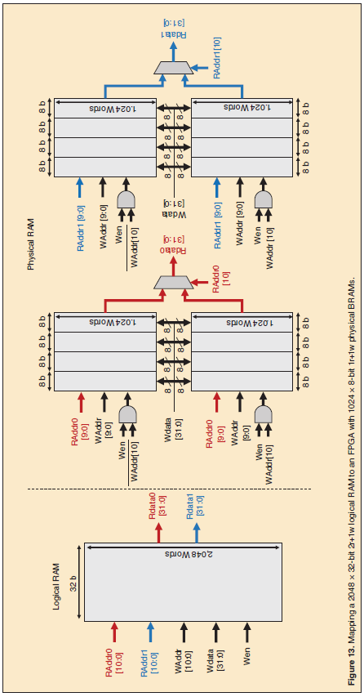
2r/1w to 2r/2w (dual-port)

DSP Blocks (Digital Signal Processing)
Multipliers must be implemented in the soft logic using LUTs and carry chains, incurring a substantial area and delay penalty → proposed novel implementations to mitigate the inefficiency of multiplier implementations in soft logic.
- Multiplier-less distributed arithmetic technique proposed to implement efficient FIR filter structures on LUT-based FPGAs.
- Advocating for adopting hard multipliers in subsequent FPGA architectures.
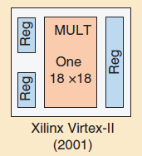
- First 18 x 18 bit hard multiplier blocks. To simplify the layout integration with the full-custom FPGA fabric, these multipliers were arranged in columns right beside BRAM columns → limiting the maximum BRAM bandwidth.
- Xilinx adopted a full-featured DSP block approach by introducing their DSP48 tiles in the Virtex-4 architecture(https://docs.xilinx.com/r/2021.2-English/ug1483-model-composer-sys-gen-user-guide/DSP48E ).
- Virtex-4 also introduced the ability to cascade the adders/accumulators using dedicated interconnects to implement highspeed systolic FIR filters with hardened reduction chains.
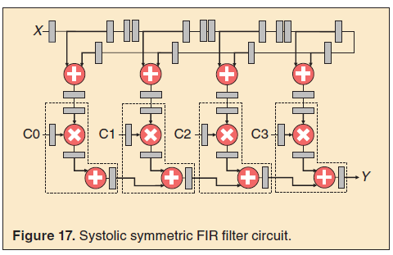
- Systolic symmetric FIR filter circuit, key use case for FPGAs in wireless base station.
- Significant efficiency gains compared to implementing them in the FPGA’s soft logic.
- 더 나은 DSP 기능을 사용하면 설계의 효율성은 떨어짐.
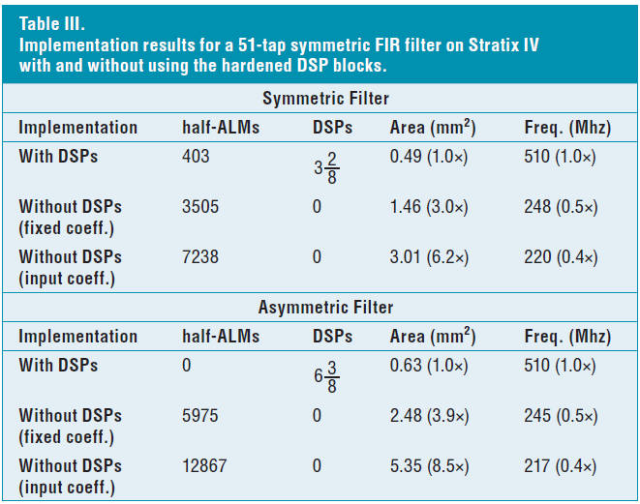
Efficient use of DSPs

Fine tune the DSP block capabilities for key application domains without adding costly programmable routing interfaces.
- Xilinx switched from 18 x 18 multipliers to 25 x 18 multipliers in their Virtex-5 DSP48E tile, after which they incorporated input pre-adders and enhanced their adder/accumulator unit to also support bitwise logic operations in their Virtex-6 DSP48E1 tile. Then, they increased their multiplication width again to 27 # 18 bit and added a fourth input to their ALU in the Ultrascale family DSP48E2 tile.

Evolving of DSP Blocks
- First direction: targets the high-performance computing (HPC) domain by adding native support for single-precision floating-point (fp32) multiplication.
- Second direction: targets increasing the density of low-precision integer multiplication specifically for DL inference workloads (int9, int4, in2 precision).
- Academic work enhanced a Xilinx-like DSP block by including a fracturable multiplier array instead of the fixed-precision multiplier in the DSP48E2 block to support int9, int4 and int2 precisions.

500MHz DSP Slices
The DSP slice forms the basis of a versatile, coarse grain DSP architecture, enabling you to efficiently add powerful FPGA-based DSP functionality to your system.
- DSP Slices have been custom designed in silicon to achieve 500 MHz performance independently or when combined together within a column to implement DSP functions.
- Each DSP Slice draws only 2.3 mW/100 MHz, at a typical toggle rate of 38%, just 6% of the power consumption of previous FPGA DSP implementations.
- The DSP Slice supports over 40 dynamically controlled operating modes including; multiplier, multiplier-accumulator, multiplier-adder/subtractor, three input adder, barrel shifter, wide bus multiplexers, or wide counters.
- Cascade DSP Slices without using FPGA fabric or routing resources to perform wide math functions, DSP filters, and complex arithmetic.
Architectural highlights of the DSP slices:
- 18-bit by 18-bit, two's complement multiplier with full precision 36-bit result, sign extended to 48 bits.
- Three input, flexible 48-bit adder/subtracter with optional registered accumulation feedback.
- Over 40 dynamic user-controller operating modes to adapt XtremeDSP slice functions from clock cycle to clock cycle.
- Cascading, 18-bit B bus, supporting input sample propagation.
- Cascading, 48-bit P bus, supporting output propagation of partial results.
- Multi-precision multiplier and arithmetic support with 17-bit operand right shift to align wide multiplier partial products (parallel or sequential multiplication).
- Symmetric intelligent rounding support for greater computational accuracy.
- Performance-enhancing pipeline options for control and data signals are selectable by configuration bits.
- Input port "C" typically used for multiply, add, large three-operand addition or flexible rounding mode.
- Separate reset and clock enable for control and data registers

